# Instruction Memory

Each instruction has its own address, marked by the 32-bit vector of the program counter. When a given instruction is needed, the Instruction Memory delivers a 32-bit wide instruction. The following considerations have to be taken into account for the Instruction Memory:

• Each instruction is one word long (32 bits).

• Each instruction is addressed by a multiple of 4 bytes (1 word).

• Each instruction lies at a multiple of 4 bytes. By contrast, the program counter counts in terms of bytes. To avoid systematic “jumps” by four instructions when the new program counter is proposed, the program counter is divided by 4.

Test:

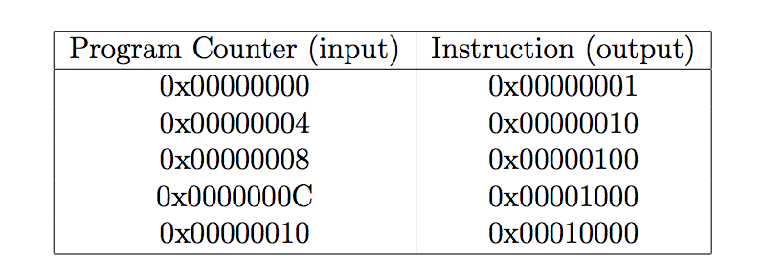

Functional Simulation:

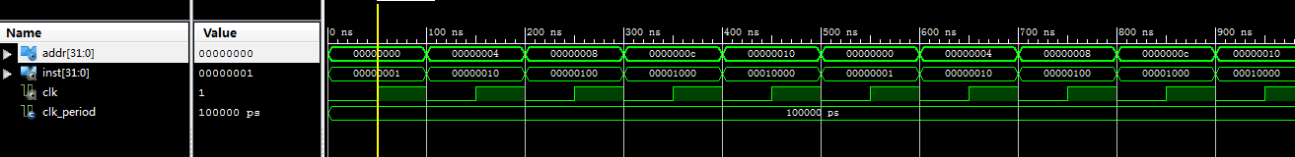

Timing Simulation:

